Kubernetes - Storage, Config Maps, Secrets, Stateful SetsFile

1.Created a namespace
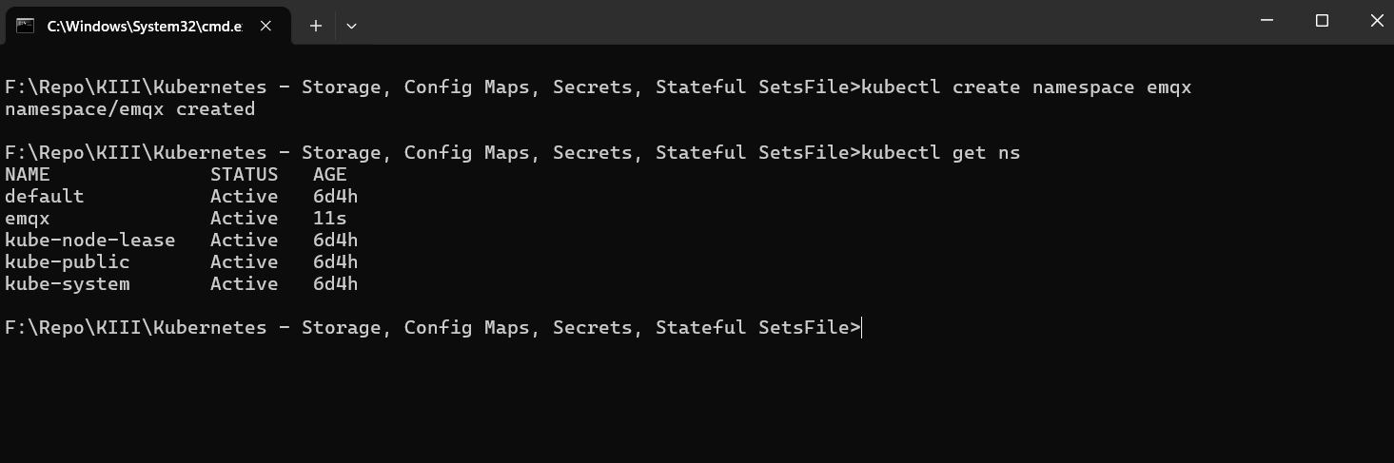
2.ConfigMap for emqx
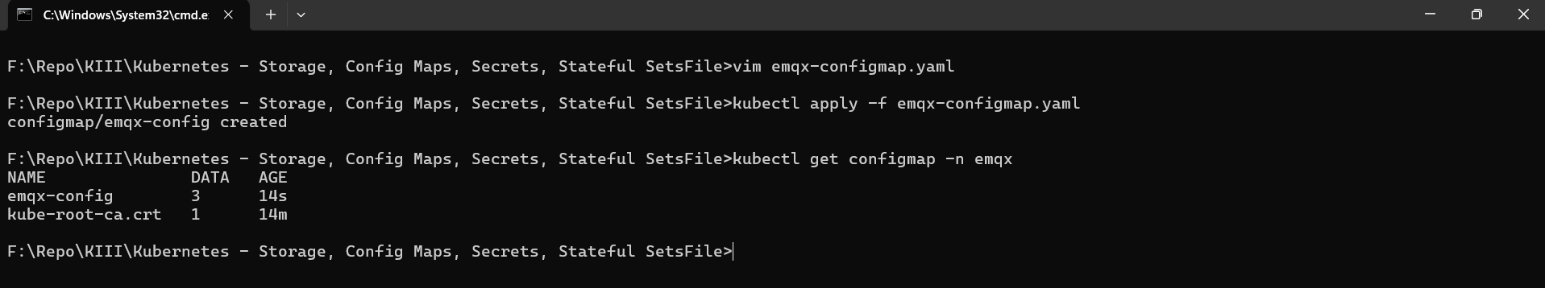
3.Headless service for emqx
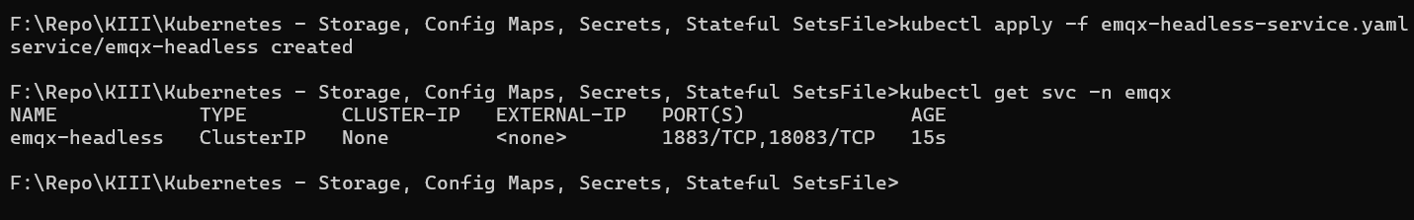
4.emqx statefulset
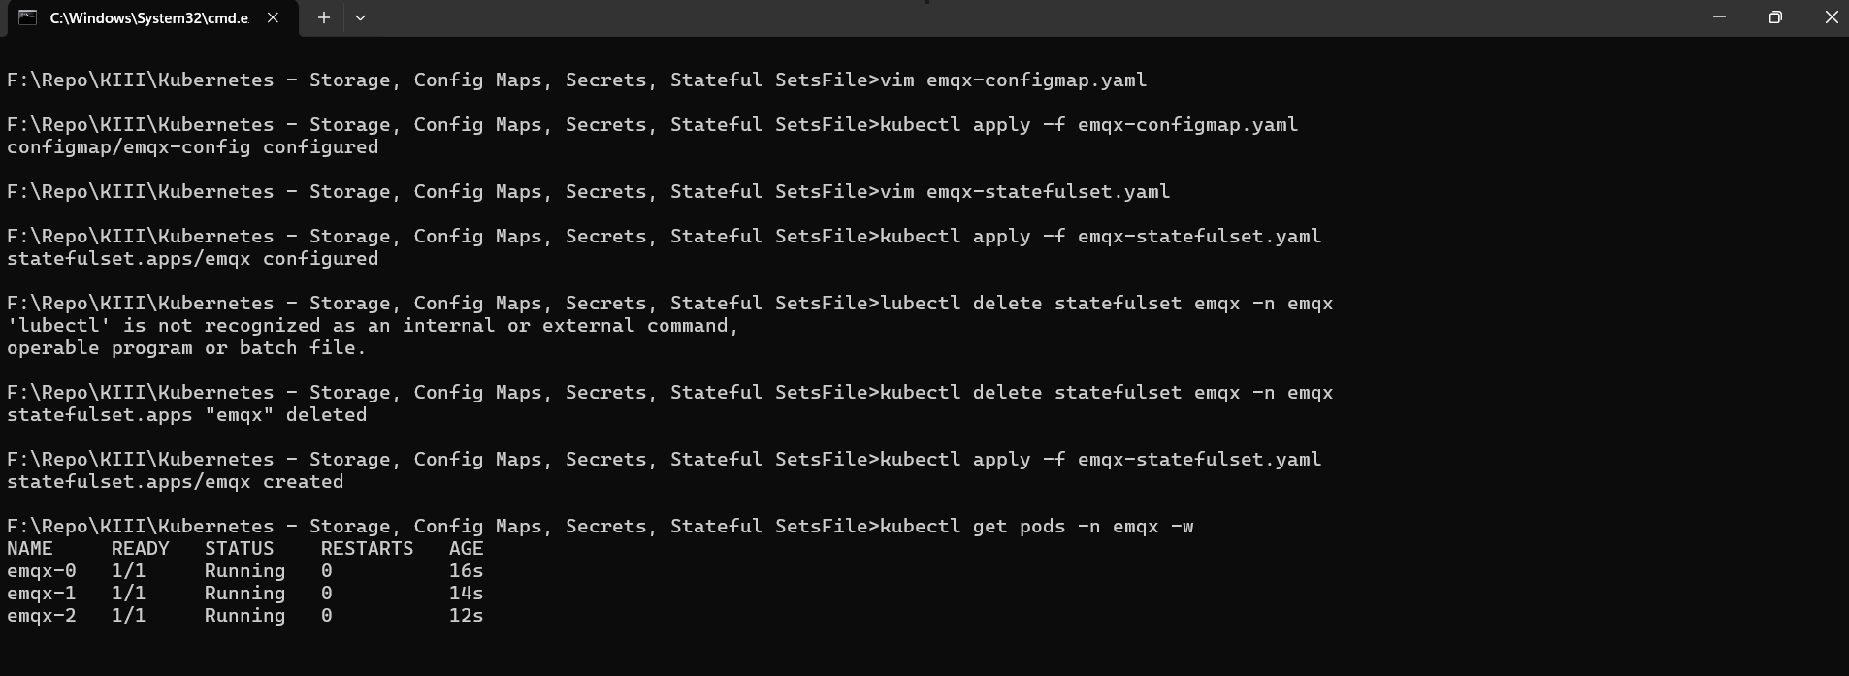

5. Validate emqx cluster
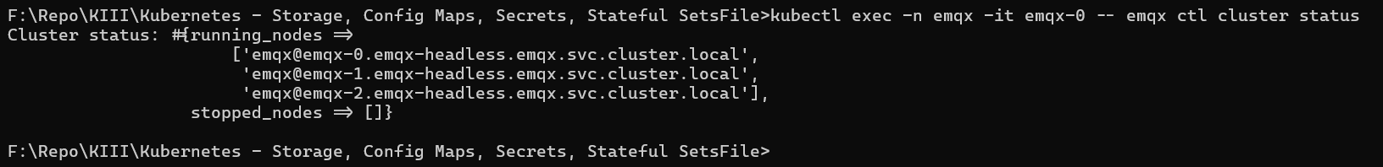

6.Dashboard emqx
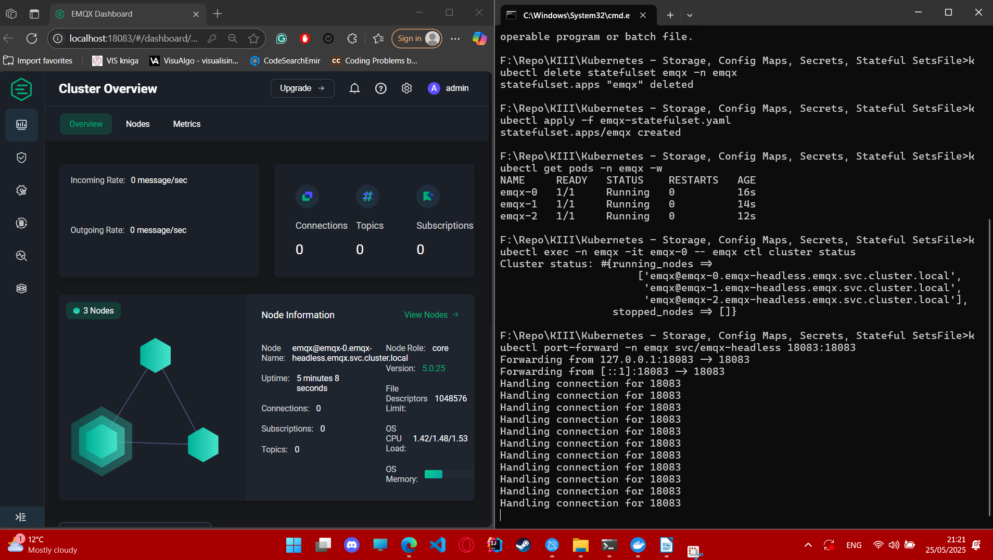

7. The code:
emqx-configmap.yaml
apiVersion: v1
kind: ConfigMap
metadata:
name: emqx-config
namespace: emqx
data:
EMQX_CLUSTER__STATIC__SEEDS: "emqx@emqx-0.emqx-headless.emqx.svc.cluster.local,emqx@emqx-1.emqx-headless.emqx.svc.cluster.local,emqx@emqx-2.emqx-headless.emqx.svc.cluster.local"

emqx-headless-service.yaml
apiVersion: v1
kind: Service
metadata:
name: emqx-headless
namespace: emqx
spec:
clusterIP: None
selector:
app: emqx
ports:
- name: mqtt
port: 1883
targetPort: 1883
- name: dashboard
port: 18083
targetPort: 18083

emqx-statefulset.yaml
apiVersion: apps/v1
kind: StatefulSet
metadata:
name: emqx
namespace: emqx
spec:
serviceName: emqx-headless
replicas: 3
selector:
matchLabels:
app: emqx
template:
metadata:
labels:
app: emqx
spec:
containers:
- name: emqx
image: emqx/emqx:5.0.25
env:
- name: POD_NAME
valueFrom:
fieldRef:
fieldPath: metadata.name
- name: EMQX_NODE__NAME
value: "emqx@$(POD_NAME).emqx-headless.emqx.svc.cluster.local"
- name: EMQX_CLUSTER__DISCOVERY_STRATEGY
value: "static"
- name: EMQX_CLUSTER__STATIC__SEEDS
valueFrom:
configMapKeyRef:
name: emqx-config
key: EMQX_CLUSTER__STATIC__SEEDS
- name: EMQX_NODE__COOKIE
value: "secretcookie"
ports:
- containerPort: 1883
- containerPort: 18083
volumeMounts:
- name: emqx-data
mountPath: /opt/emqx/data
volumes:
- name: emqx-data
persistentVolumeClaim:
claimName: emqx-pvc
volumeClaimTemplates:
- metadata:
name: emqx-data
spec:
accessModes: [ "ReadWriteOnce" ]
resources:
requests:
storage: 1Gi

